INSTALANDO MY-SQL NO DEBIAN 11

Table of Content
- Ensuring the server is Up to date
- Set up the repo for mysql 8 installation
- Installing Mysql 8 server
- Starting and enabling mysql service
- Testing mysql installation

1. Ensuring the Server is Up to date
Before proceeding, let us ensure that our debian server is up to date. Use this command to update the server packages:

sudo apt update
sudo apt upgrade -y

Next, let us install common packages that we will need in our tutorial
sudo apt install -y curl vim

2. Set up the repo for mysql 8 installation
Mysql server 8 is not available in the default Debian repositories. The mysql team provides a downloadable .deb file that will configure the repositories for mysql server 8 installation. Download it with this command:

curl -LO https://dev.mysql.com/get/mysql-apt-config_0.8.20-1_all.deb

You should see an output almost similar to this:

$ curl -LO https://dev.mysql.com/get/mysql-apt-config_0.8.20-1_all.deb
% Total % Received % Xferd Average Speed Time Time Time Current
Dload Upload Total Spent Left Speed
0 0 0 0 0 0 0 0 --:--:-- --:--:-- --:--:-- 0
100 35548 100 35548 0 0 104k 0 --:--:-- --:--:-- --:--:-- 104k

Once the download is done, we need to install the downloaded deb file. Use this command to install:

sudo dpkg -i ./mysql-apt-config_0.8.20-1_all.deb

# CASO TENHA PROBLEMAS E QUEIRA REMOVER O MYSQL DA SOURCE.LIST
apt-get purge mysql-apt-config

This will open a configuration window prompting you to choose mysql server version and other components such as cluster, shared client libraries, or the MySQL workbench.
For now since we are only interested in the Mysql Server Installation, leave the default (Mysql Server and cluster) settings and click OK to proceed.

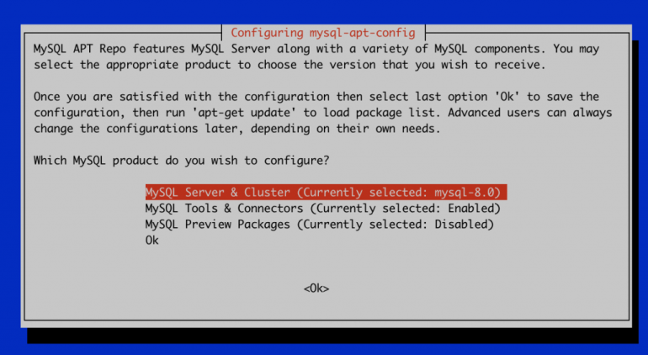
This is the output on successful installation and configuration.

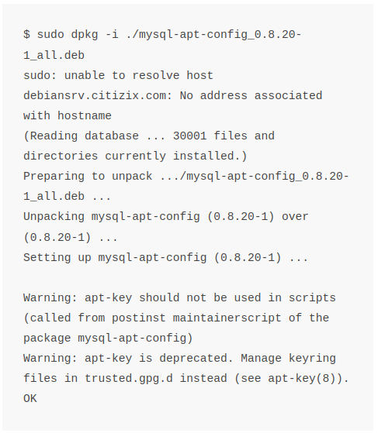

.
.

____________________________________________________________________________________

OUTROS COMANDOS PARA A REMOÇÃO:
Removendo o WorkBench:

Remoção padrão:
sudo dpkg -r mysql-workbench-community
Remoção Completa:
sudo dpkg --purge mysql-workbench-community

REMOVENDO O MYSQL:
sudo apt remove mysql mysql-server

sudo apt autoremove

# CASO ENFRENTE PROBLEMAS COM CHAVES APT-KEYS… USE ISTO:

sudo apt-key adv --keyserver hkp://keyserver.ubuntu.com:80 --recv-keys 6494C6D6997C215E

E DIGITE:
sudo apt-get update

Sendo 6494C6D6997C215E a Chave a ser adicionada NESTE CASO

# CASO QUEIRA REMOVER A CHAVE

sudo apt-key del 6494C6D6997C215E

Sendo “6494C6D6997C215E” a chave a ser removida.

____________________________________________

3. Installing Mysql 8 server
Now that the repos have been added to include mysql server, we can now install the mysql-server package.
First, refresh the repositories to get the latest from the added repo:
sudo apt update
Then Install Mysql 8 Server using this command:
sudo apt install -y mysql-server
Enter your administrator credentials, and the system will install the MySQL server package, client packages, and database common files.

The installation will prompt you to enter and confirm a root user and password for the MySQL database.

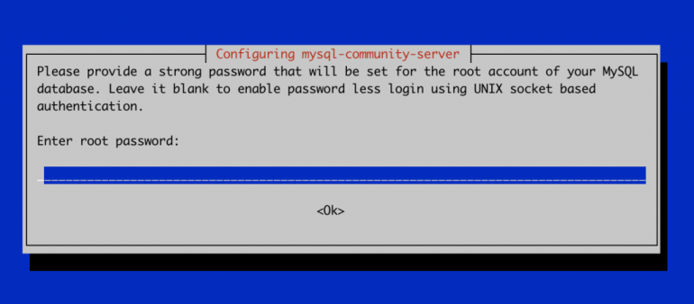
Use this command to check the info of the installed package to confirm that we installed the mysql version that we want:

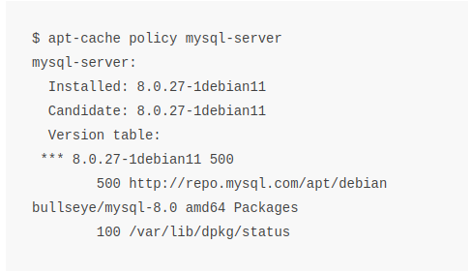

4. Starting and enabling mysql service
In debian, Mysql server will be styarted by default. Check the status of the service to confirm that it is actually running:

sudo systemctl status mysql
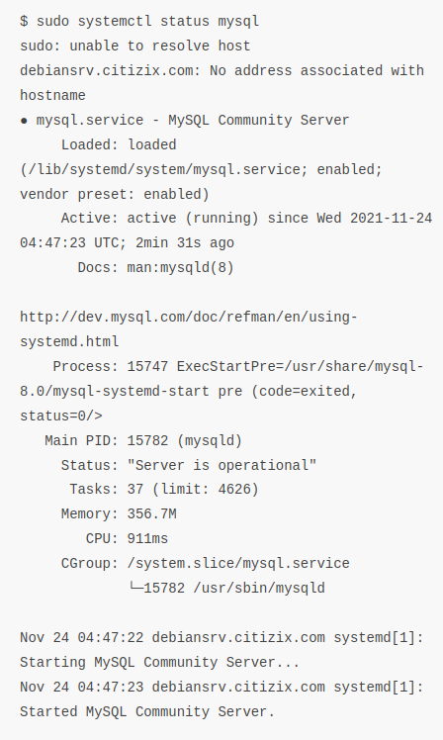

The Active: active (running) since … indicates that the service is up and running.

To enable the service to start on reboots, use this command:
sudo systemctl enable mysql

To view the MySQL 8 service log as follows using the journalctl command:

$ sudo journalctl -u mysql -xe
$ sudo tail -f /var/log/mysql/mysqld.log

5. Testing MySQL Installation
Let us check mysql version with this command:
$ mysql -V
mysql Ver 8.0.27 for Linux on x86_64 (MySQL Community Server – GPL)

Now you can Login as the root user and the password specified above.

$ mysql -u root -p
Enter password:
Welcome to the MySQL monitor. Commands end with ; or \g.
Your MySQL connection id is 8
Server version: 8.0.27 MySQL Community Server - GPL

Copyright (c) 2000, 2021, Oracle and/or its affiliates.

Oracle is a registered trademark of Oracle Corporation and/or its
affiliates. Other names may be trademarks of their respective
owners.

Type 'help;' or '\h' for help. Type '\c' to clear the current input statement.

mysql> select version();
+-----------+
| version() |
+-----------+
| 8.0.27 |
+-----------+
1 row in set (0.00 sec)

mysql>

Conclusion
In this article, we managed to install and test mysql 8 installation on Debian 11.

FONTEs:
https://citizix.com/how-to-install-mysql-server-8-on-debian-11/

# OUTRA PÁGINA MUITO UTIL:
https://pt.linuxcapable.com/how-to-install-the-latest-mysql-8-on-debian-11/

________________________________________________________

sudo systemctl status mysql
Exemplo de saída:
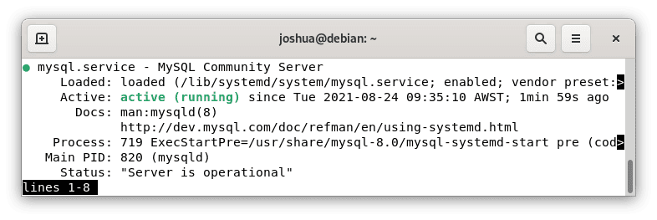
Para parar o serviço MySQL:
sudo systemctl stop mysql
Para iniciar o serviço MySQL:
sudo systemctl start mysql
Para desativar o serviço MySQL na inicialização do sistema:
sudo systemctl disable mysql
# PARA ATIVAR
service mysql start

INSTALAÇÃO DO WORKBENCH:

A UNICA VERSÃO QUE FUNCIONOU (A DURAS PENAS TENTANDO INSTALAR POR LINHA DE COMANDO = NÃO FUN, PELO G-DEB (NO DEBIAN) NÃO FUNCIONOU) SOMENTE USANDO O “INSTALAÇÃO DE PROGRAMAS” FUNCIONOU !
EM FIM, A UNICA VERSÃO FOI A PARA UBUNTU 18. A VERSÃO 20 NÃO FUNCIONOU TBM.
28/04/21 -> NENHUM SOFTWARE QUE NÃO TENHA SIDO BAIXADO DO SITE OFICIAL DA ORACLE FUNCIONOU.

INFORMAÇÕES DE LOGIN DO SITE DA ORACLE:

Nome de Utilizador:
diksonnn@gmail.com

Senha:
Arphi@360

VERSÃO QUE USEI:

mysql-workbench-community_8.0.20-1ubuntu18.04_amd64.deb

Em:
https://dev.mysql.com/downloads/file/?id=494868

EDITE O ARQUIVO:
/etc/locale.gen
(Usei o editor KATE mesmo).

ENCONTRE E DESCOMENTE A LINHA:
# en_US.UTF-8 UTF-8
(Ou seja tire o # dela (pra quem for mais leigo)).
AINDA COMO SUPER USUÁRIO DIGITE O COMANDO:
sudo locale-gen
O resultado será o seguinte:

“Generating locales...
en_US.UTF-8... done
pt_BR.UTF-8... done
Generation complete.”

INSTALE O WORKBENCH:

-> su
-> Senha root

-> sudo dpkg -i mysql-workbench-community_8.0.20-1ubuntu18.04_amd64.deb
-> sudo apt install -f

-> sudo dpkg -i mysql-workbench-community_8.0.20-1ubuntu18.04_amd64.deb

TUDO PRONTO ! -> PODE ABRIR O WORKBENCH E FAZER DE TUDO NORMALMENTE!!

WORKBENCH POR SNAP:

sudo snap install mysql-workbench-community

APÓS INSTALAR USANDO SNPA:
Use este comando para autorizar o funcionamento do WorkBench/Snap:

sudo snap connect mysql-workbench-community:password-manager-service :password-manager-service

FONTES:
https://linuxhint.com/install-mysql-workbench-debian-11/
https://stackoverflow.com/questions/42671914/mysql-workbench-not-saving-passwords-in-keychain

